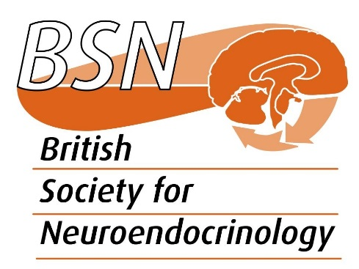

Trustee nomination form

To be returned to the General Secretary (neil.evans@glasgow.ac.uk) by 7 August 2020

Name of nominee:

Position:

Institution:

Membership category:
- Ordinary (Full)
- Student
- Research technician
- Retired

Main areas of research:

Proposers must be Ordinary Members of the BSN

First proposer:

Second proposer:

Reasons why you would like to join the Trustee Committee (max 150 words)

British Society for Neuroendocrinology, Charitable Incorporated Organisation number 1163115

