
BRITISH SOCIETY FOR NEUROENDOCRINOLOGY
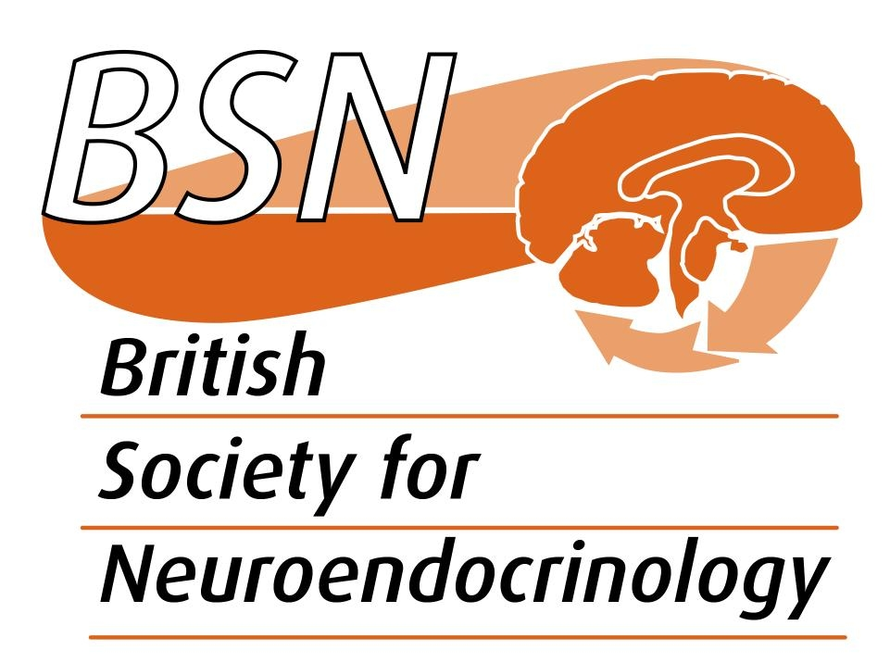

PROJECT SUPPORT GRANT
RULES
Eligibility

- Applicants must be non-tenured post-doctoral researchers or Academic/Faculty staff who apply on behalf of a student.
- Applicants must have been a full member of the BSN for at least 6 months.
- Non-UK based BSN members are eligible to apply. See website for details on how to join the BSN http://www.neuroendo.org.uk/
- Students nominated for project support by academic staff must also become BSN members.
- Applicants who have received funding in the past may apply again under the grant scheme however subsequent applications will be assessed in open competition with other applications and further funding is not guaranteed. Previous awardees will need to demonstrate that a past grant has been used productively and has led to funding applications elsewhere. Previously unsuccessful applicants under this scheme are encouraged to reapply
- Applicants who have had active participation in the BSN or previously published in the Journal of Neuroendocrinology will be looked on favourably.

Summary

- Strictly to provide support for consumables/other research costs to enable postdoctoral scientists or students to carry out the best possible neuroendocrine research project. This will allow early career researchers (postdocs or students) to get an excellent research experience with the objective that this will help them to perform independent neuroendocrine research or enable students to experience neuroendocrinology and encourage them to remain in the field.
- Funds can be used flexibly to provide salary support where full justification is made. For such applications, a letter must be included from the researchers Institution assuring that, if funded, the BSN would not carry any contractual liability to the researcher.
- The scheme can benefit BSN members who are in the early stages of their independent career, or those who have limited grant income, in providing leverage for them to compete for studentships to train students in their labs or to complete pilot experiments necessary for major external grant applications.
- The scheme is intended to support early career scientists, either PhD studentships, or small projects. It will also provide resource for MRes and where appropriate undergraduate projects.
- Awards will be up to a maximum of £7000 for identified consumables/research costs. Up to 12 awards will be made available per year, with two rounds of funding per year (Feb, Aug).

Application form and deadlines

- Please complete the application form, which can be downloaded from the BSN webpages.
- Full justification for the grant is required.
- Deadlines for application will be 1st February and 1st August each year.
- Applications must be made in advance and late or retrospective applications will not be considered.

Please submit your application by e-mail to theteam@neuroendo.org.uk
Post-award financial queries should be directed to theteam@neuroendo.org.uk in the first instance.

