
BSN Early Career Researcher Travel Grant
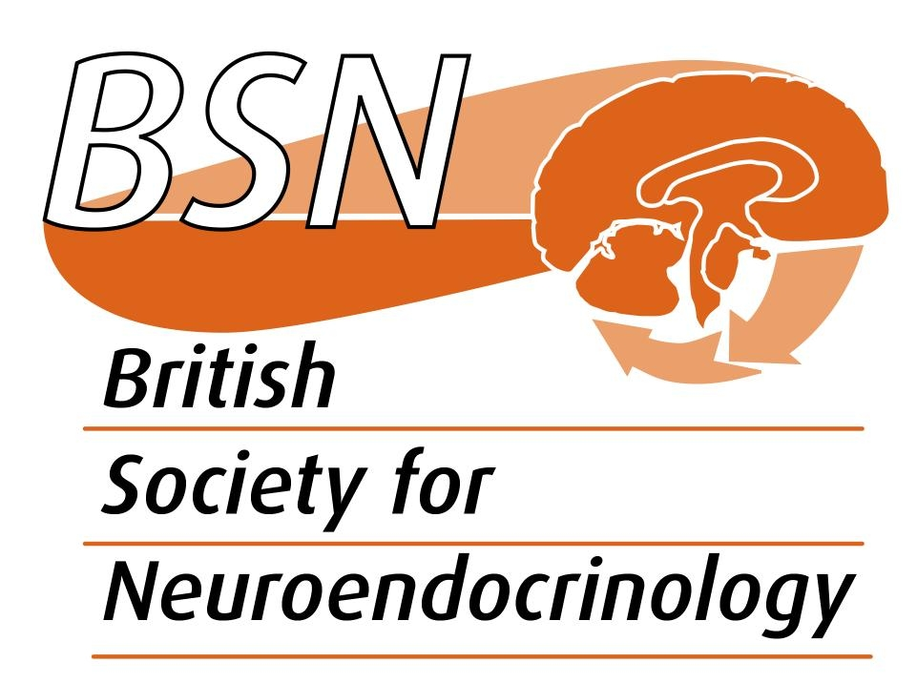

Application form

Please note that support for student travel to the ECR Symposium, Glasgow 9th December 2019 (second class rail fares or equivalent), is only available to students or to post-docs within 10 years of completing their PhD (excluding career breaks). You must have been a member of BSN for at least 6 months.

Full name:

Email address:

Institute:

BSN Membership Number:

Position:

Date awarded PhD:

Are you an ECR? YES NO

Proof of Registration Included? YES NO

Have you submitted an abstract/are you presenting? YES NO

Please give details below of approximate travel/accommodation costs

Costs Details

Transport
Accommodation

Total

Please return this form to the Membership Team at theteam@neuroendo.org.uk before the meeting, together with proof of registration. Any financial queries should be directed to the Membership Team.

