British Society for Neuroendocrinology/
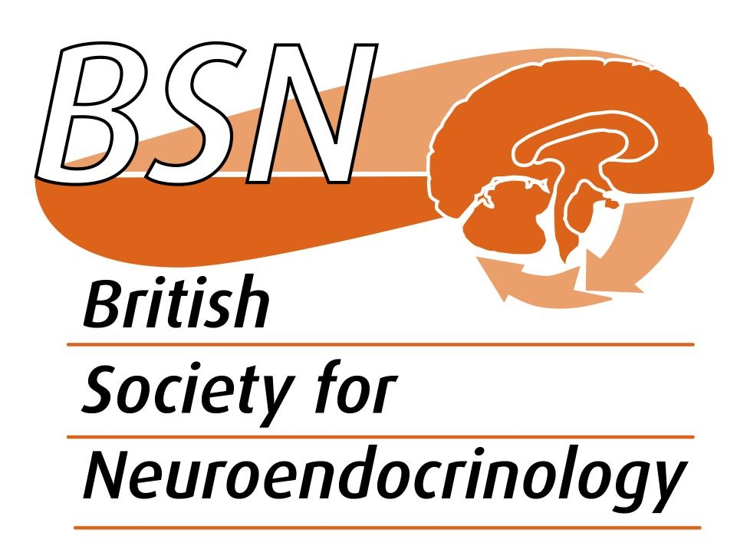

Journal of Neuroendocrinology (BSN/JNE)

Application for financial support for a scientific symposium or meeting that promotes neuroendocrinology or neuroendocrinologists

Grant application form – FOR BSN MEMBERS ONLY

Please read the rules for the operation of this fund (available on the BSN website) and complete all sections of this form, expanding space as necessary.

Applicants must have been members of the BSN for at least 6 months. All full members of the BSN (UK and international), including Early Career Researchers (within 10 years of PhD excluding career breaks), can apply, and sponsored meetings can take place anywhere in the world.

There are no specific deadline dates, but you must leave adequate time for applications to be reviewed and considered by the Editor-in-Chief of Journal of Neuroendocrinology and by the BSN Grants Panel Co-ordinator. Funding requests in excess of £2000 for BSN-badged 1- or 2-day meetings will be assessed by the BSN trustees.

Section 1: applicant details

- Name and address.

Please provide work/study address and email

2. Current position.

Please indicate whether tenured/early career researcher etc

Section 2: conference details

3. Conference name, location and dates.

Is the event for which you are seeking sponsorship part of a bigger meeting, or is it stand alone e.g. a satellite?

4. Symposium title and agreed speakers

Are you organising and seeking financial support for a specific symposium? If this is the case, please provide as much detail as possible.

Is there any scope for output from the symposium (reviews or original articles) being submitted for consideration for publication in Journal of Neuroendocrinology? NB. This is not a prerequisite. Please contact the Journal Office to discuss and for more information if you think this may be possible.

Section 3: cost details

5. Outline of costs of running the above symposium.

Please provide a full breakdown of the likely costs (including any quotations if applicable)

Have other organisations been approached to provide funding? If so, which organisations and at what funding level? What conditions were attached, if any, to funding from other organisations?

6. How much are you requesting from the BSN? (Max £2000)

Section 4: justification

7. Please provide a summary detailing why BSN/JNE should support your meeting.

8. What are the likely benefits to the neuroendocrine community?

9. How will you acknowledge sponsorship from BSN/JNE?

Please submit your completed application by e-mail to: the BSN Membership Team (theteam@neuroendo.org.uk) copying j.mercer@abdn.ac.uk in to the email.

