
British Society for Neuroendocrinology/
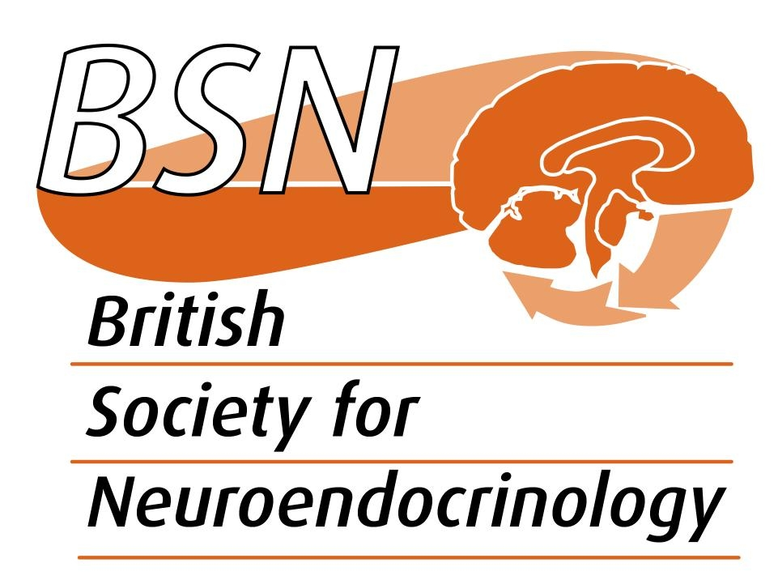

Journal of Neuroendocrinology (BSN/JNE)

Application for financial support for a scientific symposium or meeting that promotes neuroendocrinology or neuroendocrinologists

Grant application form – FOR BSN MEMBERS ONLY

Please read the rules for the operation of this fund (available on the BSN website) and complete all sections of this form, expanding space as necessary. Applicants must have been members of the BSN for at least 6 months. All members of BSN are eligible – this is an international fund. There are no specific deadline dates for applications but you must leave adequate time for applications to be reviewed and considered by the Editor-in-Chief of Journal of Neuroendocrinology and by the BSN Committee.

Section 1: applicant details

- Name and address.

2. Current position.

Section 2: conference details

3. Conference name, location and dates.

4. Symposium title and agreed speakers

Section 3: cost details

5. Outline of costs of running the above symposium.

6. What level of funding is requesting from the BSN? (Max. £2k)

Section 4: justification

7. Please provide a summary detailing why BSN/JNE should support your meeting.

8. What are the likely benefits to the neuroendocrine community?

9. How will you acknowledge sponsorship from BSN/JNE?

Please submit your completed application by e-mail to: the BSN Membership Team (theteam@neuroendo.org.uk) copying j.mercer@abdn.ac.uk in to the email.

